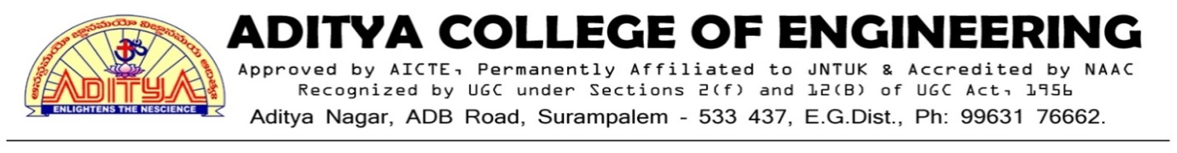

**TO WHOMSOEVER IT MAY CONCERN**

This is to certify that number of students undertaking project work/fieldwork/internship for the Academic year 2021-2022.

|  |  |  |  |
| --- | --- | --- | --- |
| Year | No.of Students undertaking Projectwork | No.of Student undertaking Internship | No.of Student undertaking Fieldwork |
| 2021-2022 | 555 | 372 | 437 |
| TOTAL | | | 1364 |

**1.3.2 NUMBER OF STUDENTS UNDERTAKING PROJECT WORK/FIELD WORK/ INTERNSHIPS FOR THE ACADEMIC YEAR 2021-2022.**

|  |  |  |  |  |  |
| --- | --- | --- | --- | --- | --- |
| **S.No** | **Programme Name** | **Program Code** | **No.of Students undertaking Project work** | **No.of Student undertaking**  **Internship** | **No. of Student undertaking**  **Fieldwork** |
| 1. | B.Tech Civil Engineering | 1 | 34 | 23 | 63 |
| 2. | B.Tech Electrical & Electronics Engineering | 2 | 67 | 24 | 112 |
| 3. | B.Tech Mechanical Engineering | 3 | 81 | 37 | 18 |
| 4. | B.Tech Electronics & Communication Engineering | 4 | 233 | 247 | 63 |
| 5. | B.Tech Computer Science Engineering | 5 | 113 | 41 | 127 |
| 6. | Master of Business Administration | 0 | 27 | - | 54 |



**1.3.2 NUMBER OF STUDENTS UNDERTAKING PROJECT WORK/FIELD WORK/ INTERNSHIP FOR THE ACADEMIC YEAR 2021-2022.**

|  |  |  |  |  |
| --- | --- | --- | --- | --- |
| **Programme Name** | **Program Code** | **List of Students Undertaking Project Work/Field Work/ Internship** | | **Link to the Relevant Document** |
| B. Tech Civil Engineering | 1 | Project |  |  |
| Internship |  |  |
| Field Work |  |  |
| B.Tech Electrical & Electronics Engineering | 2 | Project |  |  |
| Internship |  |  |
| Field Work |  |  |
| B.Tech Mechanical Engineering | 3 | Project |  |  |
| Internship |  |  |
| Field Work |  |  |
| B.Tech Electronics & Communication Engineering | 4 | Project |  |  |
| Internship |  |  |
| Field Work |  |  |
| B.Tech Computer Science Engineering | 5 | Project |  |  |
| Internship |  |  |
| Field Work |  |  |
| Master of Business Administration | 0 | Project |  |  |
| Internship |  |  |
| **Total Number of Students** | | 1364 | | |