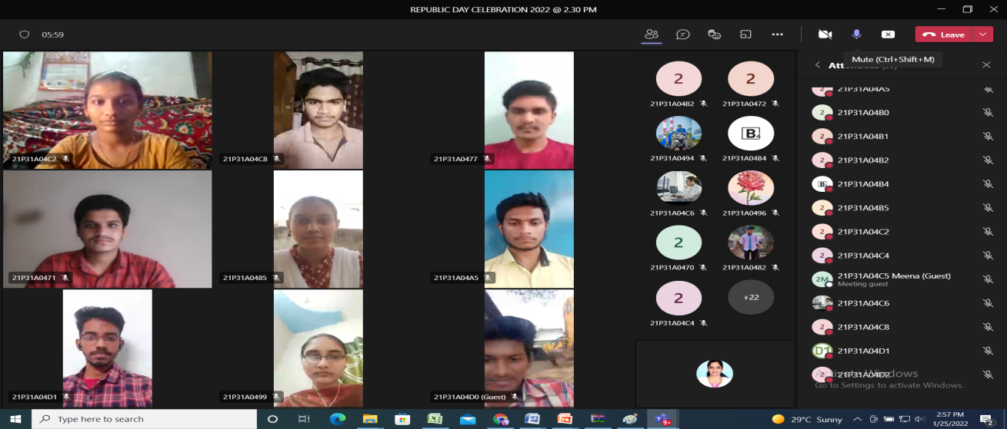

Online Republic Day Celebrations on 25th January 2022

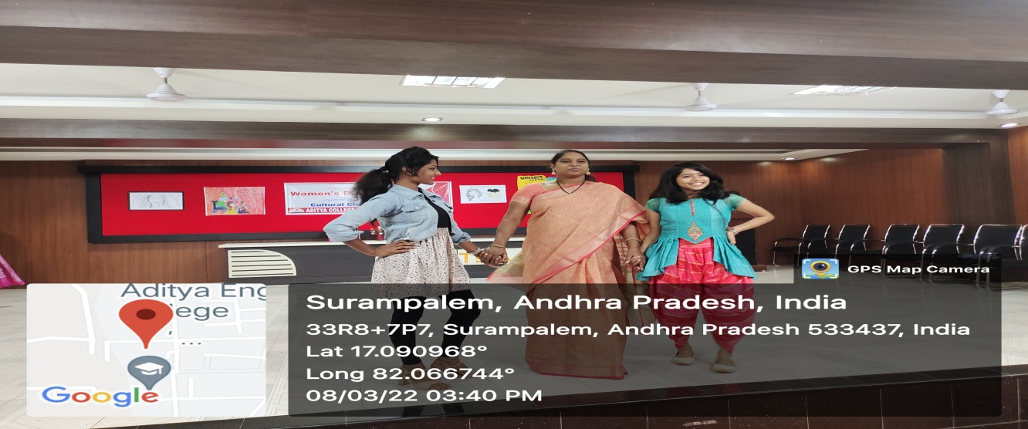

WOMEN’S DAY celebrations on 8th March 2022

Fashion walk with Dr.Pavani Reddy, the chief guest along with Sonam and sakshi

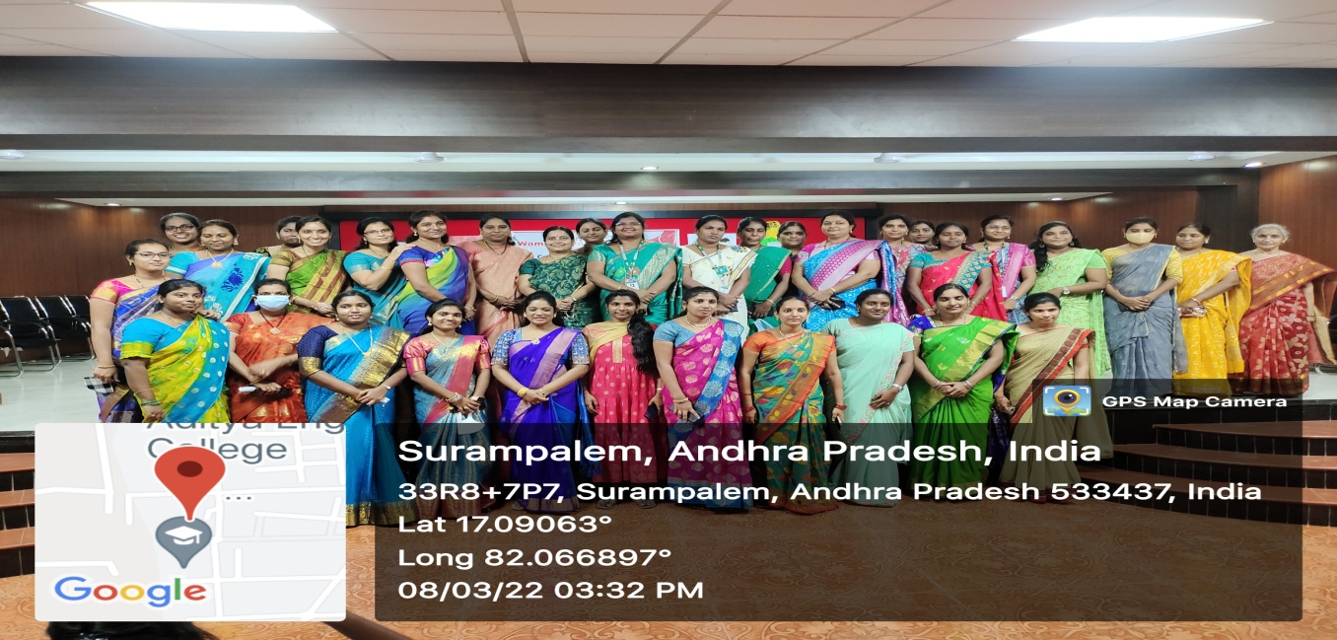

The Beauty and powerful women of ACET on the occasion of Womens day 2022

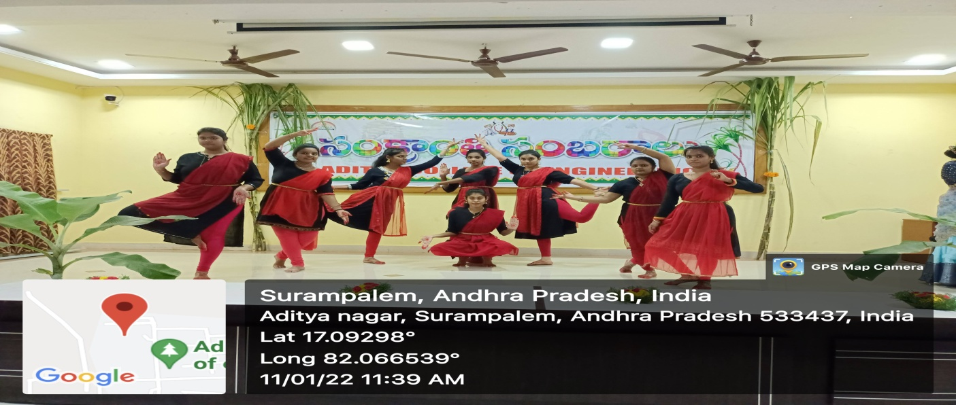

Pongal 2022 Celebrations

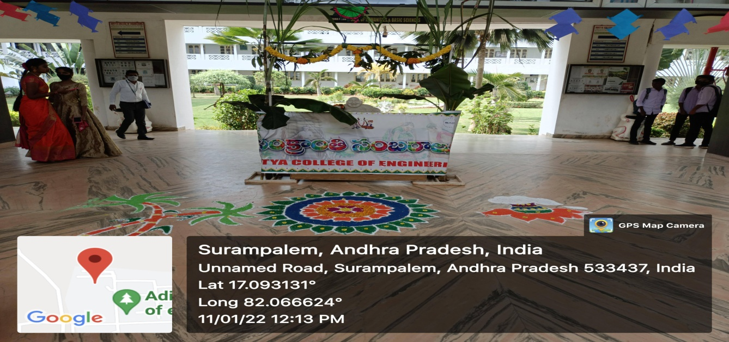

Pongal 2022